Literature Review and Problem Elaboration

BUG BOUNTY

Project Code:
091215

Internal Advisor:
Mr Farooq Javid

Project Manager:
Dr. Muhammad Ilyas

Project Team:
BSEF19M015 Fareeha Rani
BSEF19M009 Aqsa Yaqoob
BSEF19M012 Faiza Shahbaz

Submission Date:
11/10/2022

_____________________
Project Manager’s Signature

Document Information

Category | Information
Customer | CS & IT, UOS
Project | <Project Title>
Document | Literature Review and Problem Elaboration
Document Version | 1.0
Identifier | PGBH01-2020-RS
Status | Draft
Author(s) | BSEF19M015 Fareeha Rani  BSEF19M009 Aqsa Yaqoob  BSEF19M012 Faiza Shahbaz
Approver(s) | PM
Issue Date | Sept. 11, 2022
Document Location
Distribution | - Advisor: Dr Muhammad Illyas  - PM: Mr Farooq Javid

Definition of Terms, Acronyms and Abbreviations

Term | Description
nmap | Network Mapper
CVSS | Common Vulnerability Scoring System
IBM | International Business Machines
SOW | Statement Of Work
URL | Uniform Resource Locator

Table of Contents

1. Abstract 4
2. Background and Justification 5
3. Problem Statement 4
4. Literature Review 6
6. References 12

Abstract
This document provides a literature review about bug bounty, technical personnel performing the test and the organization being tested. Bug bounty project is about finding vulnerabilities in a host system or web application and further exploiting the vulnerabilities providing the client, the organization or a person hiring pen testers to test their website, a glimpse of how many issues will be present in a full-fledged working Web App. Important point under discussion will be objectives, benefits provided, background, and the methodology used. Steps involved in project methodology: Gathering the information, Pre-exploitation, Post exploitation and Report creation. It further discusses how to apply methodology provided to conduct penetration testing.

Background and Justification
Cyber technology is being used for carrying out cybercrimes for political, personal strategic gains, or economic. One of the early pioneers in penetration testing development was James P. Anderson. According to Symantec, an internationally renowned cybersecurity firm, “Pakistan is among the top ten countries most vulnerable to cyberattacks,” (Jibran, 2021).
  - Background
External network penetration testing was performed on target system i.e., UOS web application. They used organization's internal network and infrastructure to assess vulnerabilities. Internal network penetration discovered potential problems; they discover the consequences of a severe breach by identifying the exposed information. The used impressive variety of protocols to assess the robustness of the threat detection and response, automated system was used to assess vulnerabilities.
The system used windows operating system. Through constant scanning the team discovered open ports in the system through nmap, these ports posed a great source of threat to the system, some of these included FTP, HTTP, MYSQL, Netbios.ssn, msrpc, Microsoft.ds, Ms-sql-s. The elaborative scan also exposed the protocols used by these ports. Common protocols were RDP, SMB, FTP. The penetration testing team tried to compromise system and services, providing insight into any network vulnerabilities, both in terms prevention and response.
Incoming and outgoing network traffic was observed and scanned and Network service provider was exposed. The team discovered that HECPERN-AS-PK PERN content service provider was being used by target organization. The network traffic was graphically shown they monitored the network traffic using Etherapp that displayed sniffed graphical traffic through the system's network
The team performed authenticated scanning; the tester performed the scans as an intruder would, without trusted access to the network. This revealed vulnerabilities that can be accessed without logging into the system. The team discovered open port i.e., telnet through which server could locally connect. Furthermore, the routing path was also scanned and discovered, an exposed path can lead to configuration and connectivity of the network thereby exposing routing to targeted attacks on key nodes or links. The scanning on routing paths using TraceRoute exposed routing paths posing high vulnerability severity on the system network.
Comprehensive security testing also included internal network penetration testing services, looking at the threats from the attackers that already have a foothold in the network including external attackers with access to authentication data like usernames, passwords. The team used BurpSuite proxy with which incoming requests were intercepted and credentials like Username, Password were read and eventually exposed. in addition, the organization was exposed to be using a vulnerable template that exposed it's PHP code and modules used in website (Hassan Shahid, 2020).
  - Justification
Our bug bounty project is to identify security vulnerabilities of our target system, evaluate the effectiveness of the security strategy to see if its specified measures create an effective defense when followed, evaluate your complete attack surface and find any vulnerabilities in equipment that face the outside, and to determine if your external controls adequately mitigate risk and keep out bad actors
The past project worked on, Server scanning, different servers of the department (such as data center server, examination server) were scanned using network penetration testing methodology, internal network was assessed for vulnerabilities. (Hassan Shahid, 2020)
What makes our project different is that:
- Type of test we are performing which includes: Web Application Testing, Websites.
- The project is a penetration test
- Not only the vulnerabilities are assessed but also exploitation is also performed.
- when specified vulnerabilities are found, CVSS will be used to rank the severity of the found vulnerabilities and their common possible impact on the system

Problem Statement
Bug bounty programs generally requires group of researchers having a group of skill sets, techniques and expertise in order to create a diverse working platform for finding vulnerabilities as casting more eyes on something leads to more discoveries.
But hunting bugs can be challenging based on some prominent factors like time, cost and incident response pan.
According to a report In 2020, the average time took to identify a vulnerability was 207 days and the cost to mitigate the data breaches was $3.86 million.(IBM, Cyberint) despite having some serious loopholes in the systems and their underlying devastating impacts, some organizations still do not pay much attention to mitigate and patch of these vulnerabilities simply because they do not give them enough importance or they do not want to spend their time and expenditure on such tests considering them wastage of cost and resources.
  - SOLUTION
We can’t fix it if we don’t know where it’s broken! Pen testing team will go beyond finding security gaps and actively and try to exploit those vulnerabilities to see if a hacker could actually access data. It’s like an MRI for Target organization's infrastructure in that it looks for problems that may not have developed symptoms yet. It will be a true test of the effectiveness of existing protections and it will clearly reveal where organization is leaving doors open for cybercriminals to enter.
We, the Bug bounty hunters, use our skills to make the target system or web application a safer place from intruders. So even if it is a small vulnerability or a severe one, we are content that at least we somewhat contributed on our end. As we move forward, it takes advanced agreement and planning with security testers and teams, developers and operations to ensure that the procedures to tackle security related issues when, they arise, are in place. But all in all, the challenges, risks and the issues of bug bounty programs are significantly outweighed by the benefits that are achieved by the of bug bounty programs. Every day, in Pakistan and around the world there are new breaches grabbing attentions as they hit the news headlines. Bug bounties are one of the ways to continue on the path to a safer digital life and help the organization keep out of those headlines.
A pre-testing consultation will be held to discuss the process and needed preparations. The SOW will be defined and timelines for completion will be established. The penetration test will be performed, penetration testing will then lead to making and presenting Network Penetration Test Assessment Report (Baloch).

Literature Review
Today's society is called information society these days those who have right information have more power and value of some information is immeasurable. if such information is stored in a computer system it must be ensured that system is secured properly without any vulnerabilities and possibility of theft. because more and more confidential information, like medical reports, is being stored electronically on computer systems and those systems are often connected to computer networks. This represents new challenges for people working in information technology. They have to ensure that those systems are as much secure as possible and confidential information will not be revealed.
One possible way how to prove system security is to conduct regular penetration tests” e.g. simulate attacker's malicious activity. This research briefly introduces the basics of penetration testing and shows how to deploy and use Metasploit framework when conducting penetration testing.

  - IN DEPTH REVIEW
The following research provides a deep and detailed study on the penetration testing, our main goal and the common methodologies and tools used to perform it.it further mentions the financial and business benefits one would gain from this pen test, and the risk factor involved in the process.
  - Scope of project
Web application penetration testing will be performed All the domain associated with the website will be tested. It will not be performed on the servers or the internal network of the organization. it will not be performed on internal network of the organization. Vulnerabilities associated with the website will be assessed and exploited.

Why penetration testing?
Since excessive amount of data and information is being stored on computer systems through network it develops a new challenge for the security providers. Computing system professionals use penetration testing to address problems inherent in vulnerability assessment, focusing on high-severity vulnerabilities. Penetration testing is a valued assurance assessment tool that benefits both business and its operations.

  - BUSINESS AND FINANCIAL GAINS
- Discover vulnerabilities from an attacker’s perspective so that weak points can be fixed.
- Gaining the trust of customers and investors by ensuring the security of their products and data.
- Assess the severity of the discovered vulnerabilities
OUR MAIN GOAL
- To identify and eliminate security vulnerabilities of our target system.
- Evaluate the effectiveness of the security strategy to see if its specified measures create an effective defense when followed.
- Evaluate your complete attack surface and find any vulnerabilities in equipment that face the outside.
- Determine if your external controls adequately mitigate risk and keep out bad actors

  - Project Methodology
The methodology of penetration testing includes following phases (Aileen G. Bacudio, 2011):

- Information Gathering
The general information about the target and the scope provided will be discussed in this phase. Penetration testing involves gaining as much information about the target system as the testers can from important information such as design, logic flows of the web application ranging to irrelevant and useless information. Every piece of information related to the website is collected which could prove a vulnerability later in the testing phase.
- Pre-exploitation
Pre-exploitation phase includes usage of tools, techniques and methods to further gain information about the target system or web application. Pre-exploitation phase involve the following activities (Habib, 2016).
- Reconnaissance
Reconnaissance includes the activities performed by the testers to collect necessary information about the target such as the usernames, passwords etc.
- Discovery And Scanning
The information gathered is used to perform discovery activities to determine things like ports and services that were available for subdomains or targeted hosts, available for web applications.
- Vulnerability Assessment
Vulnerability scanning is conducted in order to gain initial knowledge and identify any potential security weaknesses that could allow an outside attacker or tester to gain access to the system being tested

- Exploitation
In this phase the actual tests are performed by the tester after the results from the vulnerability assessment are interpreted, penetration testers will use manual techniques, their backgrounds to validate, and attack, and exploit those vulnerabilities.
- Post Exploitation
Post exploitation involves activities that allows the testers to identify the value of the vulnerabilities found during the exploitation phase. Post exploitation phase involves activities
- Final Analysis and Review
The report generated at the end of the testing phase which includes information such as the initialization of the tests and the vulnerability assessment and lastly the exploitation of the vulnerability. It includes the scope of the testing, test methodologies used, and corrections recommendations.
- Testing Results Utilization
The findings from the security testing must be used by the organization to risk rank vulnerabilities and analyze the impact of vulnerabilities, determine strategies of remediation, and inform decision-making moving forward
Tools
Some systems include tools for a range of security testing. One example among many is the Kali Linux (Bhalla, 2021), used in digital forensics and penetration testing. It contains eight standard security tools including Nmap, Aircrack-ng, Kismet, Wireshark, Metasploit Framework, Burp Suite and John the Ripper which allows a single system to have so many penetration testing tools. The available options for penetration testing are highly specialized and numerous. Many systems include tools for a range of security testing of the operating system. The more the sophisticated today’s technology has become and the ways ingenious hackers are discovering to create mischief in shared computing environments, especially the Internet.
  - Diagram
- Context Diagram
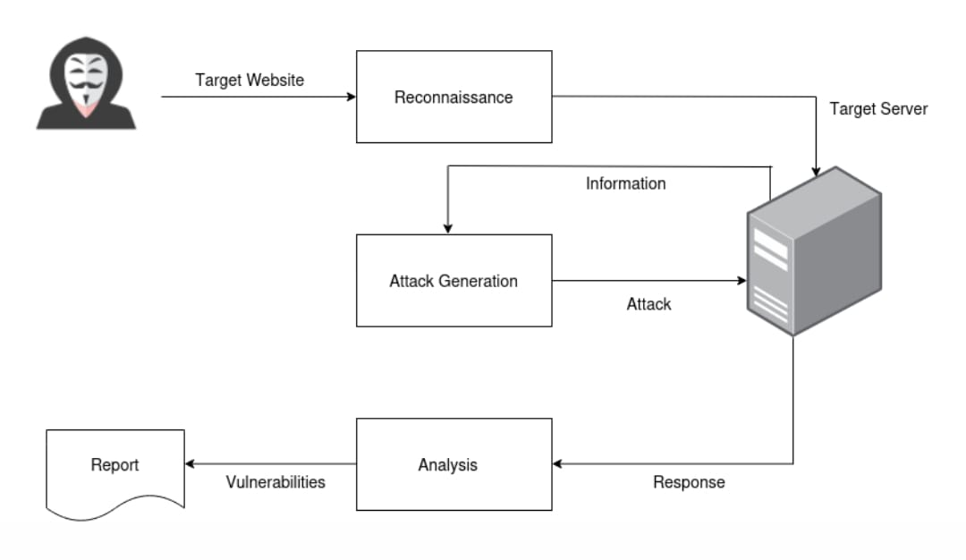

- Work Flow Diagram
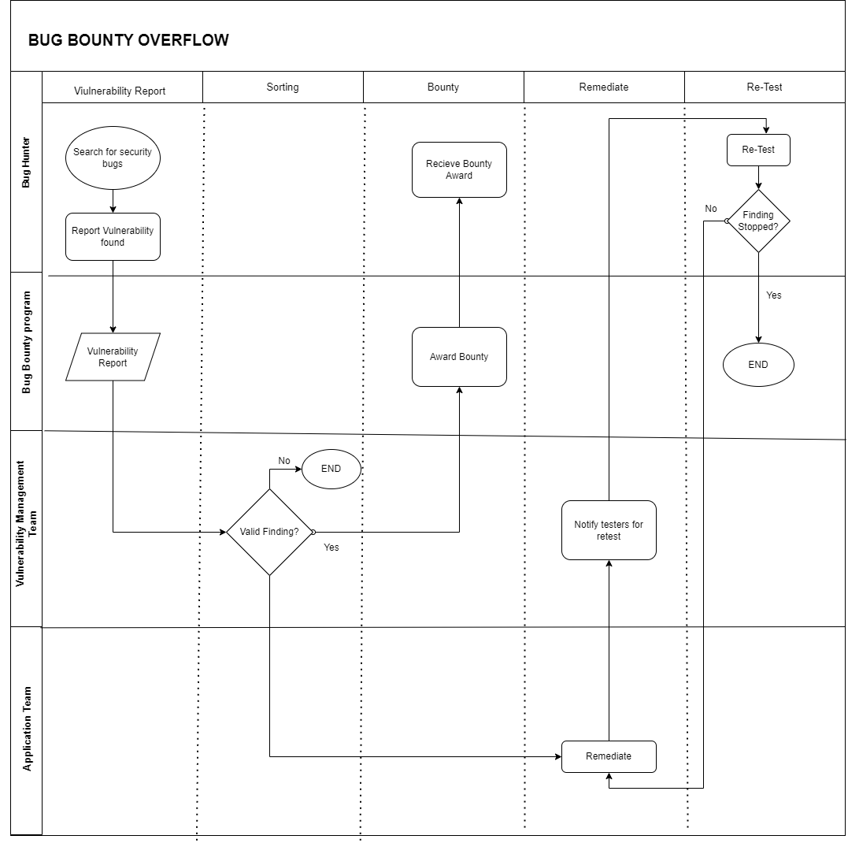

- Usecase

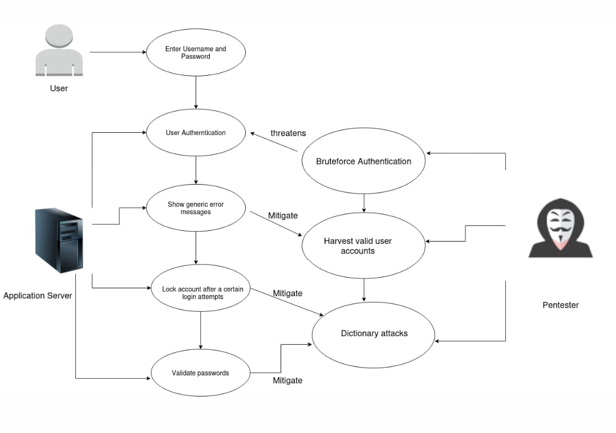
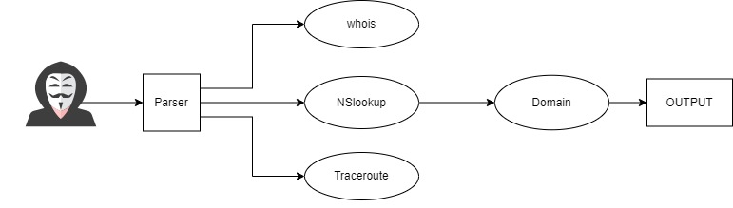

  - APPLIED STRATEGY

Two approaches to penetration testing are used commonly one of them comes first normally,

The Breadth First approach emphasizes thorough coverage, and practitioners tend to rely heavily on automated tools to accomplish all or much of the testing. This approach means a heavy reliance on the most dangerous tools – automated scanners. While generally cheaper this approach is dangerous and can miss important findings depending on the amount of manual testing employed.

The Depth First approach emphasizes undetected penetration in depth, and practitioners of this approach tend to avoid the use of automated tools because those tools can draw attention. Depth First practitioners use far more manual effort and often consider an engagement to be unsuccessful if they are not able to fully compromise a system or expose deeper systems. This approach often results in inadequate breadth of coverage, is usually more expensive and can expose deeper systems to unnecessary risk. A balance must be maintained between the two approaches for better stability and smooth testing procedures.
Furthermore, we are using two more techniques to perform pen testing these techniques include:
- Black box testing
In black box pen test tester is only provided with the URL of the website and nothing else. Black box pen test involves series of tests performed on a particular target and pen tester having no prior knowledge of it. Blackbox pen test has resemblance to blind test.
- External Testing
External testing is a series of cyber-attacks performed by the pen testers from an outside source and test how far they gain control of the target or the host system

  - RISK FACTOR IN PENETRATION TESTING
Performing testing on the system can impact systems directly and indirectly. Direct, negative impact to systems can occur even with very well-known and trusted tools used by almost every security firm, such as the venerable Nmap port scanner. Suitability failures occur when testing engagements fail to cover necessary scope or fail to meet other requirements imposed by owner organization. When testing outcomes result in re-work, added cost or missed deadlines, it is appropriate to consider them as risks.
Safeguards that must be taken while performing one testing in order to prevent the following potentially dangerous acts: Databases damaged when data records or referential integrity is destroyed by application scanners. Routers, switches, and other critical systems crashed by network vulnerability scanners, or even simple port scans. Systems that are simply overwhelmed by too much testing volume. Testers must perform a full manual review of all web applications before

Indirect impact occurs when non-targeted systems or processes are impacted by testing activity directed at targeted systems. These indirect impact scenarios are likely to be overlooked in penetration testing planning. In some cases, those other systems are beyond your control and the effects can be difficult to reverse.

There is no such thing as a risk-free penetration test. Penetration testing, by its nature, involves doing unexpected things to systems and people. The risk can never be completely eliminated, but it can be reduced and controlled. furthermore, Automated testing might be performed in order to speed up the testing and scanning process. large number of requests performed on the target website in the form of Ddos might prove harmful for the system causing a hault.

References

Aileen G. Bacudio, X. Y.-T. (2011). An Overview of Penetration Testing. International Journal of Network Security & Its Applications (IJNSA), Vol.3, No.6, 22-36.

Bhalla, W. (2021, August 23). The 8 Best Linux Distributions for Penetration Testing. Retrieved from makeuseof: https://www.makeuseof.com/best-linux-distros-for-penetration-testing/

Habib, M. N. (2016, March). The & Phases and Steps of Penetration Testing. Retrieved from The Nur Habib Medium: https://thenurhabib.medium.com/

Hassan Shahid, A. B. (2020). Network Vulnerabillities. Sarodha: Student of CS&IT.

Jibran, F. (2021, April 15). Cybersecurity In Pakistan: A Grave Vulnerability. Retrieved from Paradigm Shift: https://www.paradigmshift.com.pk/cybersecurity-in-pakistan-a-vulnerability/

